You Are Cordially Invited To Attend

*The Annual Banquet, Installation of Officers and Awards Ceremony of the*

Charles County Volunteer Fire and EMS

Associations

Friday, January 3, 2025

at

Waldorf Jaycees

Cocktail Hour Starts at 6 P.M. Dinner Served at 7 P.M. Awards to Follow

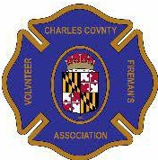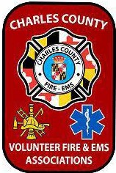

**RSVP to ANDREW SPALDING at (301) 751-6154 NO LATER THAN December 27, 2024**